What’s in it?

Subject:  Related Subjects:Chemical reactions, conductivity, mass, centrifugal force, capillary action | Grade Level(s):  Length of Lesson: | Type: Inquiry / Design / Project  Keywords: Matter, molecules, atoms, protons, neutrons, electrons, hypothesis, experiment, unknown, known quantity, solution, soluble, solvent, series circuit, current, LED, pH, acid, base

Lesson Overview
Students will create a chemistry set which will allow them to analyze samples of solids, liquids and gases for pH, starch, vitamin C, presence of metals or minerals, and iron. They will also use chromatography and centrifuges to separate particles of substances for further testing.

Lesson Focus
What is the central question or phenomenon being investigated? What problem are they trying to solve?

Lesson Objective(s) | - Students will be able to define key terms.  - Students will create a chemistry set that analyzes matter for pH, starch, vitamin C, presence of metals or minerals, starch, and iron using readily available materials.  - Students will use chromatography and centrifuges to separate particles from solutions of substances.  - Students will benchmark their chemistry sets using known quantities to authenticate results.  - Students will use pH to determine acidity of substances.  - Students will test substances for the presence of starch.  - Students will test substances for the presence of vitamin C  - Students will test substances for the presence of metals or minerals.  - Students will test substances for the presence of iron.

Lesson Timing

5 minutes | Introduce the Lesson
30 minutes | ...

Materials | - –Soldering Iron  - –Solder  - –Film canisters  - –Coffee filter paper  - –Red Cabbage  - –Pot  - –Heating coil  - –Scissors  - –Motor  - –LED  - –AA Batteries  - –Wire  - –Foam Board  - –PVC pipe  - –Base shoe wood  - –Push button switches  - –Hot glue gun  - –Hot glue sticks  - –AA Battery holder  - –push pin  - –Corn starch  - –Iodine  - –Straws  - –Vitamin C tablets  - –Total breakfast cereal (contains Iron)  - –Insulated wire  - –Lemon juice  - –Baking soda  - –Rectangle magnet
Instructor Prep | - Step 1
Related Resources | - List related lessons/ppts etc available from USC or outside, trusted orgs

Lesson Plan

Introduction

Matter is anything that has mass or takes up space, or its just stuff. This stuff is made up of little pieces called molecules. Atoms fit together to make molecules. Atoms are made up of particles called protons, neutrons and electrons. How these particles fit together is how atoms form molecules. Matter also has three primary states, solid, liquid and gaseous depending on how far apart its particles are. When atoms and molecules are put together, sometimes we get a mixture of them, and sometimes we get something new. Because Scientists have learned about a lot of different types of matter, they know how certain types of matter behave when different things are added or done to them. In other words, they know how to test things to see if they contain a certain type of matter. If the stuff they test has it, then it will behave a certain way.

Before they start, the Scientists must know how certain types of matter should behave. They then make an educated guess, called a hypothesis, about whether the new stuff, called the unknown, either is or has a certain type of matter, called a known quantity. They then test their hypothesis by doing things to the unknown that makes the known quantity behave in a certain way. This is called an experiment. If the unknown behaves like the known quantity, then the Scientist knows that the unknown either is or has part of or is similar to the known quantity.

Procedure
- –When making holes in foam board, make two perpendicular incisions and push object through
- –Label canisters with Centrifuge, Chromatography, Metal/Mineral, Starch, Vitamin C, and pH.
- –Cut an 18” x 12” rectangle of foam board.
- –Cut 2, 10” pieces of pvc pipe or base shoe wood.
- –Glue pvc or wood to the bottom of the foam board parallel to 12” side.
- –Cut and strip 2 pieces of wire
- –Strip the wires of a battery holder.
- –Solder one wire to one lead of motor.
- –Solder second wire to second lead of motor.
- –Solder the other end of wire to one lead of push button switch.
- –Solder one of battery holders wires to an other lead of push button switch.
- –Connect remaining wire to remaining battery holder wire (figure 1).
- –Test circuit with batteries.
- –With the board in landscape position, cut a small hole in the upper right corner for motor.
- –Push motor through from bottom and hot glue in place
- –Hot glue battery on top of board in place.
- –Cut a small hole in board and insert push pin from the top, so that its leads are visible from the bottom.
- –Cut a 6” x 1” piece of foam board and bend 1” from both ends.
- –Glue a film canister on each end of board. This is your sample holder
- –Glue bottom of board to top of 3rd film canister.
- –Poke a small hole in bottom of film canister just large enough for stem of motor to fit.
- –Mount 3rd canister on stem of motor and glue. Be careful not to glue canister in such a way that the motor cannot spin.
- –Drip additional glue inside canister to secure motor.
- –This is your centrifuge.
- –Attach sample holder by securing top to centrifuge.
- –Cut 1” square strips of coffee filter paper.
- –Insert into film canister and glue canister to foam board to the left of the centrifuge. Make sure centrifuge isn’t blocked.
- –Cut and strip both ends of 2 pieces of wire each 6”.
- –Cut a small hole in board and insert push pin from the top, so that its leads are visible from the bottom.
- –Strip the red and black wires from the battery holder
- –Twist the red wire around the long leg of the LED, solder and tape.
- –Twist one of the 6” wires around the other leg of the LED, solder and tape.
- –Twist the black wire with the other 6” wire and tape (figure 2).
- –Tape the battery holder to the top of the board.
- –From the bottom of the board, push the LED through the small hole and tape into place.
- –Bring the ends of the wires around to the top of the board.
- –Poke 2 pinholes, using a push pin on opposite side of the top of a film canister.
- –Push the two wires into the holes so that they are ½ inch in length but not touching.
- –Use a drop of glue to hold them in place.
- –Make a snug hole for the canister so it can be secured and removed as needed.
- – Chop one large red cabbage into small pieces.
- –Simmer the cabbage pieces until the water turns a deep shade of purple.
- –Allow the water to cool. Your pH testing solution is done
- –Pour half a teaspoon of cornstarch into the pot.
- –Pour a cup of water into the pot.
- –Heat and stir the pot of water and cornstarch solution until all the cornstarch is dissolved in the water. After heating, let everything cool.
- –Pour two teaspoons of the solution and one cup of water into one of the cups. Using the medicine dropper, add four drops of iodine into the solution. Your Vitamin C testing solution is now done.
- –Add 10 drops of iodine to a ½ cup of water. Your starch testing solution is now done.
- –Make crosshatch holes and insert the remaining canisters for testing pH, starch and vitamin C into the board.
- –Glue a rectangular magnet to the center of the board.

Instructions for Benchmarking Chemistry Testing Set

- pH
- –Pour some lemon juice into a cup.
- –Put some baking soda into a cup.
- –Place straw in the cabbage juice left in the pot and cover the end of the straw.
- –Drip some in each of the cups.
- –Observe and describe in writing what happens to the cabbage juice when it is poured onto the lemon juice and the baking soda.

- Starch
- –Put some cornstarch into a cup.
- – Place straw in the starch testing solution and cover the end of the straw.
- –Drip some in the cup.
- – Observe and describe in writing what happens to the starch testing solution when it is poured onto the cornstarch.

- Vitamin C
- –Dissolve a vitamin C tablet in a cup of warm water.
- – Place straw in the vitamin C testing solution and cover the end of the straw.
- –Drip some in the cup.
- –Observe and describe in writing what happens to the vitamin C testing solution when it is poured onto the vitamin C solution.

- Metals
- –Place a piece of metal in contact with the two wires in the film canister top.
- –Press the push button.
- – Observe and describe in writing what happens when the button is pushed.

- Minerals
- –Dissolve a lot of salt in warm water.
- –Place salt solution in contact with the two wires in the film canister top.
- –Press the push button.
- – Observe and describe in writing what happens when the button is pushed.

- Iron
- –Crush cereal and place on 3 x 5 card.
- –Pass over magnet.
- – Observe and describe in writing what happens.

- –Pour prepared solutions into the appropriately labeled film canisters.
- –Cut straws for each canister to be used to extract portions.
- –Gather unknown substance.
- –Hypothesize if substance should be tested in its original form or in an aqueous solution.
- –Prepare sample.
- –Test sample in the same manner as you did in benchmarking.
- –Observe and describe in writing your results.
- –Complete lab chart describing properties of sample.

Instructions for Using Additional features of Chemistry Testing Set

- Centrifuge
- –Prepare solution of unknown substance.
- –Pour into both canisters of centrifuge sample holder.
- –Press push button control for 60 seconds.
- –Test liquid from one canister using procedures described above.
- –Test sediment from other canister using procedures described above.
- –Observe and describe in writing your results.

- Chromatography
- –Dip coffee filter strip in water.
- –Dip edge of filter strip in unknown substance solvent.
- –Allow unknown substance solvent to move across strip.
- –Remove strip edge from solvent.
- –Conduct tests on different areas of filter paper, using separate strips for each test.
- –Observe and describe in writing your results.

Wrap-up
- Students will use chemistry set to analyze materials retrieved from land ROV.
- Students will use chemistry set to analyze materials retrieved from underwater ROV.
- Students will use chemistry set to analyze materials retrieved from airborne ROV.

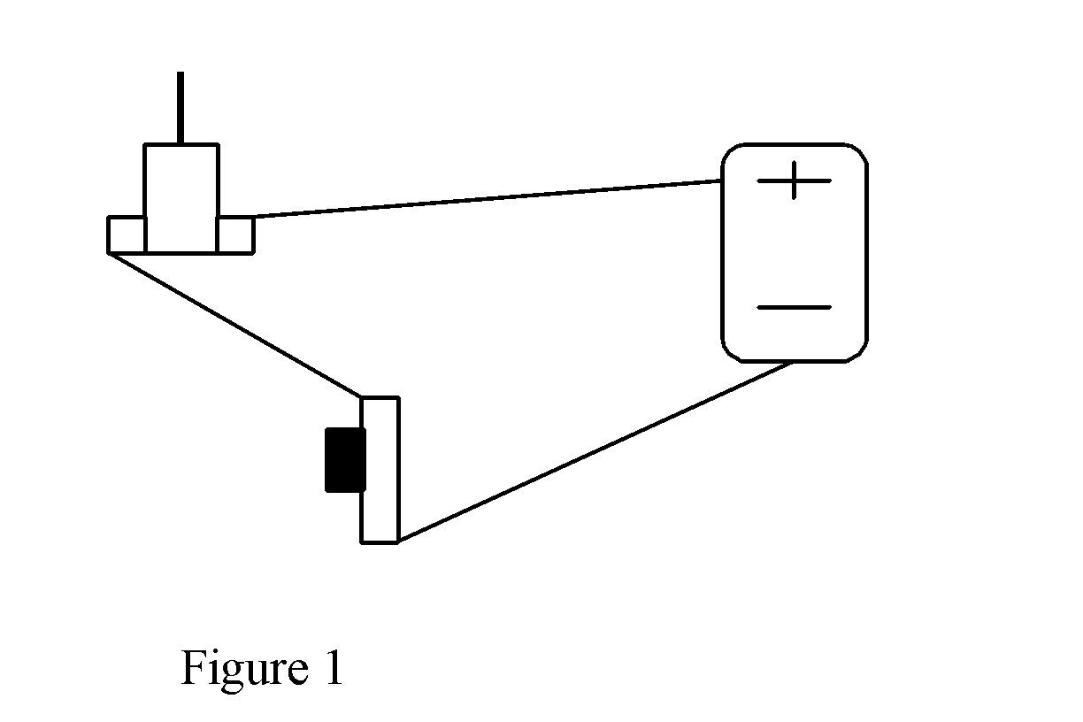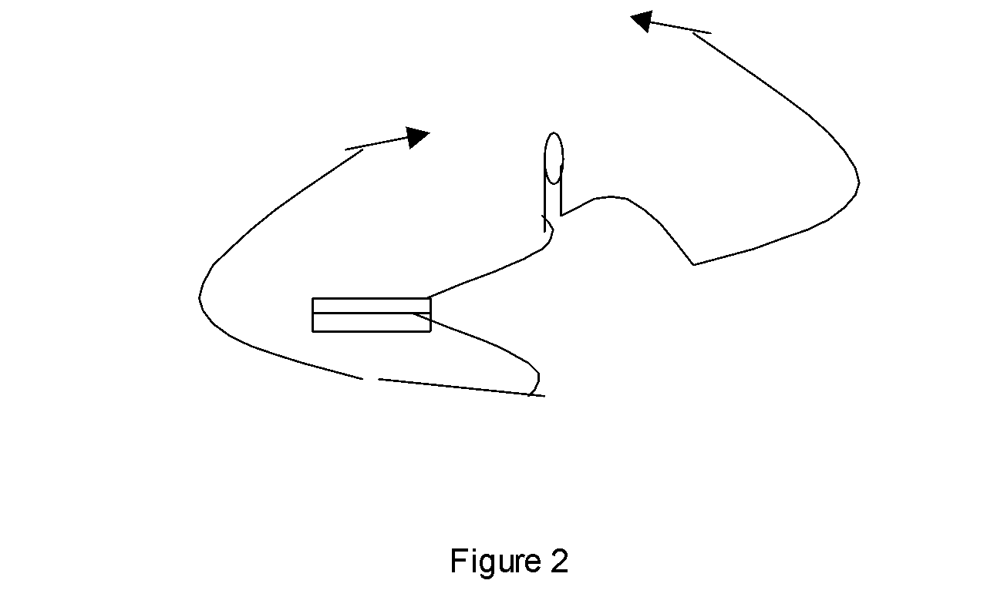

Lesson Background for Teachers

Suggested Real-World STEM Connections
- List possible related Role Models in STEM (with details and links to more reading). Give suggestions for examples of scientists/engineers who are from underrepresented groups in STEM in related careers.
- List related real-world engineering problems and examples

Lesson Variations and Options
Include descriptions of alternative methods or ways to present things.

Explanation
- pH

In chemistry, many substances change color due to reactions with other substances. Cabbage juice is an example. When cabbage juice is placed onto an acid, such as lemon juice, it will react differently when compared to cabbage juice and a base, such as baking soda. Why cabbage juice changes color remains uncertain. However, with this indicator, you can now test all sorts of things to determine if they are an acid or a base. Even though the nature of the color change is uncertain, we do know that it probably has to do with the composition of acids and bases. All acids have hydrogen ions, H+, while all bases have hydroxyl ions, OH- (notice that the combination of H+ and OH- yield water which is neutral in acidity). It is most likely the cabbage juice's reaction with these ions that stimulates the color change.
The presence of the hydrogen ion is also the basis of the pH scale. This scale is used to measure the acidity of a substance. The scale goes from 1 to 14 where 7 is neutral (water), anything less than 7 is acidic and anything greater than 7 is basic.
If the indicator turns the solution red or pink, the solution is an acid. A purple solution indicates that it is neutral, neither an acid nor a base. If the indicator turns the solution blue or green, the solution is a base

- Starch

In chemistry, many substances change color due to reactions with other substances. An example of this is iodine. Iodine turns blue whenever it is combined with starch. This is a helpful indicator as you can now test for starch just by dropping iodine onto a sample or in a solution. The more starch, the bluer the solution.

- Vitamin C

After testing for starch, the resulting blue starch and iodine solution can be used to test for the presence of vitamin C. Vitamin C causes the blue starch and iodine solution to fade. The more vitamin C, the clearer the solution becomes.

- Metals or minerals

One important property of metals is that they conduct electricity. If a substance contains metals, it can conduct electricity. . In addition, some minerals conduct electricity in water you must be sure, however, that if you mix the substance in with water, to test the water for conductivity first. Distilled or bottle water usually is metal free.

- Iron

A magnet is used to detect particles of iron. Since iron is attracted to magnets, the presence of iron in a substance can be easily determined.
- Paper Chromatography

Chromatography is useful for separating materials from each other. As water is absorbed by the paper (we will use a coffee filter), some substances are carried further than others. The reasons can vary from the weight of the different substances to their electrical charge, to their ability to dissolve in water. Nonetheless, chromatography allows you to test different components of a substance. The method consists of applying the test solution or sample as a spot near one corner of a sheet of filter paper. The paper is initially wet with some suitable liquid (called a solvent) to create a stationary liquid phase. An edge of the paper close to the spot is then placed in another liquid with a substance in which the components of the mixture are soluble in varying degrees. The solvent penetrates the paper by capillary action and, in passing over the sample spot, carries along with it the various components of the substance. The components move with the flowing solvent at speeds that are dependent on their solubilities in the stationary and flowing solvent. Separation of the components is brought about if there are differences in their relative solubilities in the two solvents. Before the flowing solvent reaches the farther edge of the paper, both solvents are evaporated, and the location of the separated components is identified, usually by application of reagents that form colored compounds with the separated substances

- Centrifuge
The centrifuge is used primarily for the separations of liquids from liquids or of very fine particles for liquids. Heavier particles than the suspending liquid tend to migrate toward the outside, while lighter ones move toward the center. The speed with which the movement occurs is dependent on the spinning speed, the difference between the weight of the particle and that of the suspending liquid, the thickness of the liquid, the size and shape of the particle, and to some extent the amount of the particles and the electrical charge. A practically complete separation of the suspending medium and the suspended particles can be produced if the centrifugation is allowed to continue until all particles have collected against the outer wall of the spinning vessel or centrifuge. It should also be noted that a partial separation of two groups of suspended particles of different size can be effected by allowing centrifugation to continue only long enough for all of the larger particles to be completely packed into the sediment, since then many of the small particles will still be suspended in the fluid. If separation of the larger as well as the smaller particles is desired, the surface fluid can be drawn off and the sediment resuspended in some suitable liquid and subsequently centrifuged again to effect further separation.

Key Concepts and Vocabulary
- Word 1: Grade Appropriate Definition
- Word 2: Grade Appropriate Definition

Safety Notes
- Students should not eat or drink any of the solutions. They are poisonous.
- Students should exercise extreme caution when dealing with hot objects and surfaces.
- Students should exercise extreme caution when dealing with sharp objects.

